|  |  |  |  |  |  |
| --- | --- | --- | --- | --- | --- |
| Date | 6-Dec-22 | | | Tester Name | Andrew McLaughlin |
| Environment | Penfax - Test | | | Login used |  |
| Operating System | Windows | Version: | Update: | | |
| Software Used | Edge | Version: | Update: | | |
| Select Software | Version: | Update: | | |
| Release version | 22.4.1 | | | | |
| Title | Run indexing on selected Payment Amount Types and ensure indexing amounts are correct - will run on smaller plan when testing | | | | |
| Test Type | Regression | | | | |
| Test Scenario | Run indexing on selected Payment Amount Types and ensure indexing amounts are correct - will run on smaller plan when testing | | | | |
|  |  | | | | |
| Expected Results |  | | | | |
| Pass/Fail | Pass | | | JIRA# | N/A |

Describe your steps with screenshots:

Run pre-indexing query for a small plan like ATLS – **Query Available on Page 3 here**: H:\Quality Assurance\Prod Apps\PenfaxV5\MEPP\Procedures\How to Run Indexing in Penfax 5.docx

Apply indexation rate for ATLS with benefits commencing 01-JAN-1900, effective date the day you want them to start, for **every Recipient Type**. 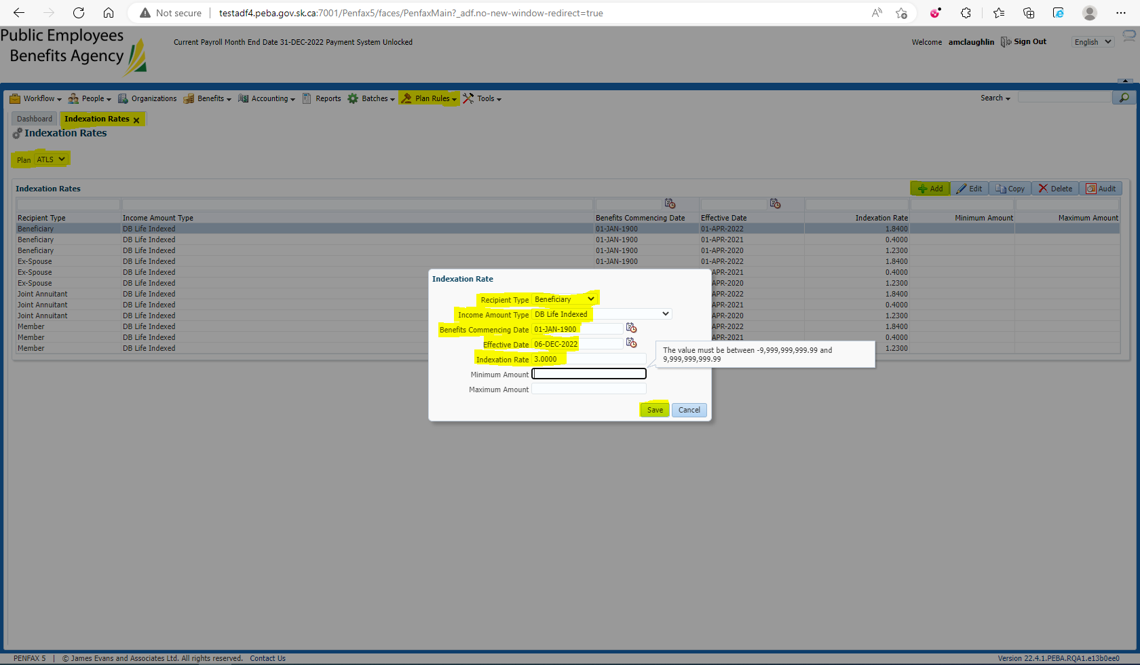

Run the Indexation Batch for the Plan 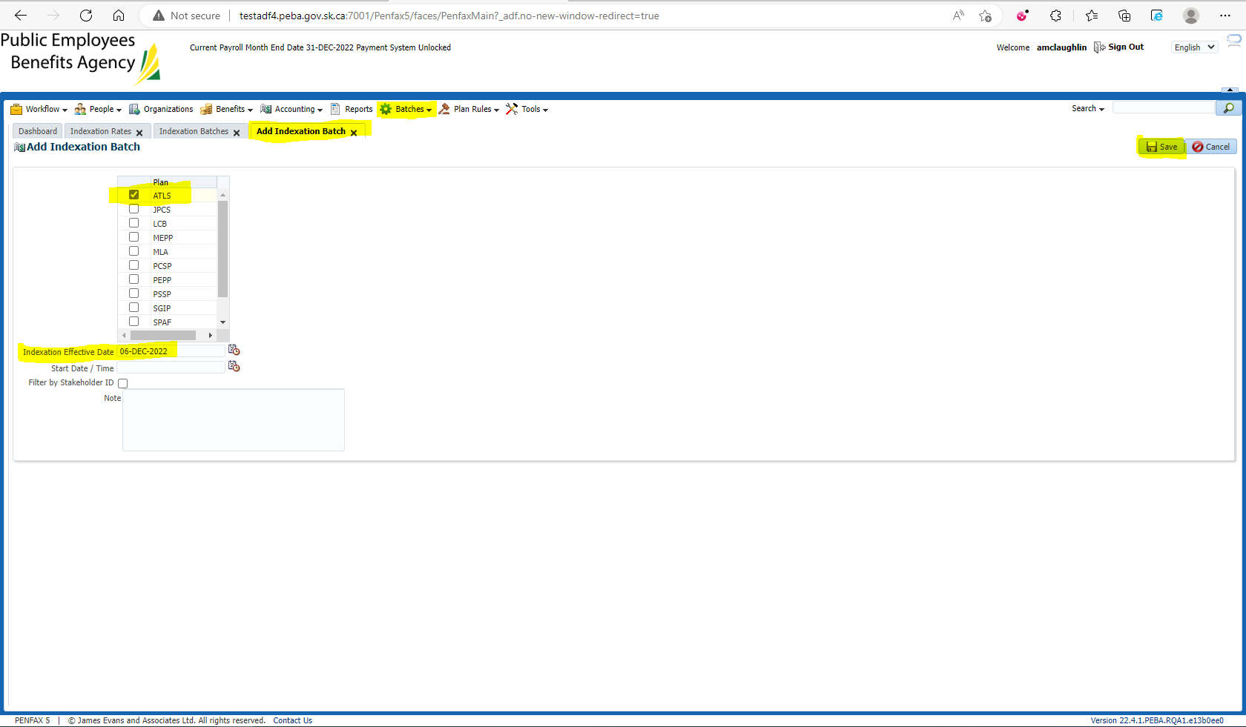

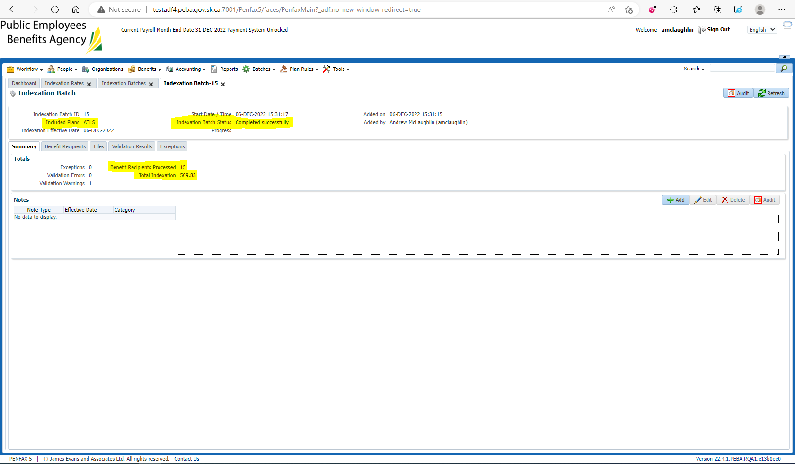

Run post indexing query for ATLS **Query Available on Page 5 here**: H:\Quality Assurance\Prod Apps\PenfaxV5\MEPP\Procedures\How to Run Indexing in Penfax 5.docx

Compare the amounts b/w pre and post indexing query results 